AGENDA
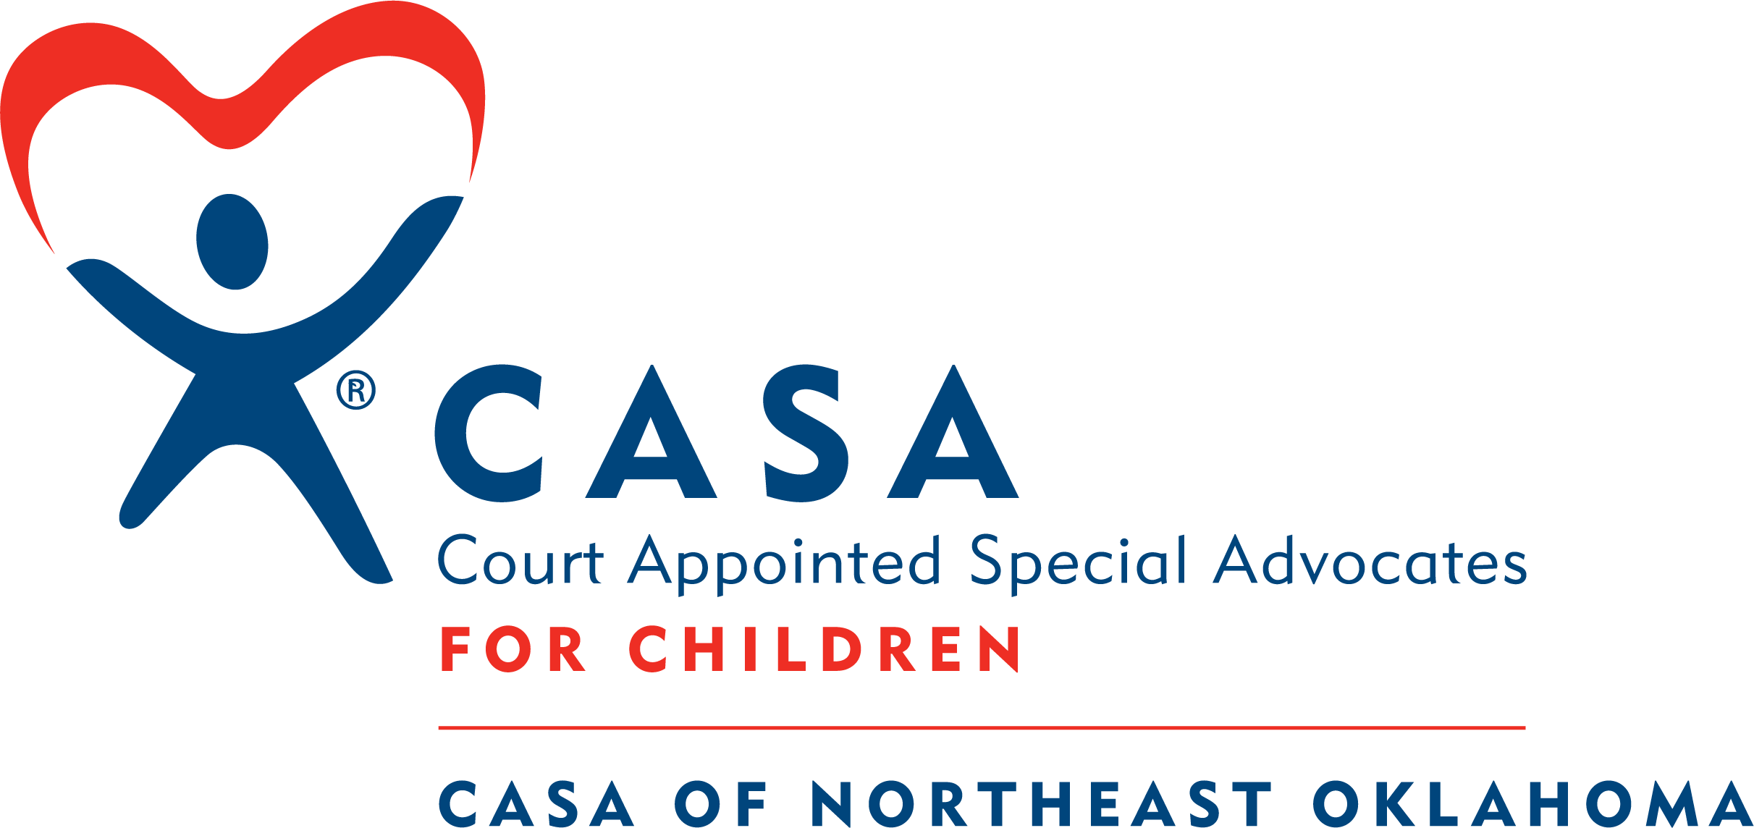
REGULAR Meeting of the Board of Directors
Thursday, November 12, 2026, 5:15 p.m.
Northeast Oklahoma Electric Cooperative
27039 S. 4440 Road
Vinita, OK 74301

REGULAR MEETING AGENDA

THE BOARD OF DIRECTORS MAY DISCUSS, CONSIDER AND VOTE ON ANY ITEM LISTED IN THIS AGENDA:
I. Call to Order – Chair, Julie Sellmeyer
II. Report of Auditor Regarding FY 2026 Financial Statements and Review of IRS Form 990 for 2025– Ober and Littlefield CPAs
III. Approve Minutes: 08/13/2026 Regular Meeting & 08/13/2026 Annual Meeting
IV. Chair’s Report and Introduction of Guests – Julie Sellmeyer
V. Director’s Report – Emily Bowling
VI. Reports of Work Groups
A. Volunteer Management Work Group (see minutes of 10/05/2026)
B. Fundraising Work Group (see minutes of 10/15/2026)
1. Discussion and Approval of 2027-2028 Fundraising Plan
C. Finance and Audit Work Group (see minutes of 10/20/2026)
1. Discussion and Approval of Financials for July, August and September 2026
2. Discussion and Approval of FY 2026 Audited Financial Statements
3. Discussion and Approval of 2025 IRS Form 990
D. Governance Work Group (see minutes of 10/22/2026)
1. Discussion of Potential Board Members
E. Executive Work Group (see minutes of 10/26/2026)
1. Discussion and Approval of Grievance Policy
2. Discussion and Approval of Diversity and Anti-Discrimination Policy
VII. New Business
The law provides that, if “New Business” is listed on the agenda, the Board can, under that item, consider and vote on any business that could not have been foreseen or known about at the time the agenda was posted.
VIII. Adjournment

Next Board of Directors Meeting: Thursday, February 11, 2027 at 5:15 p.m.
Northeast Oklahoma Electric Cooperative, 27039 S. 4440 Road, Vinita, OK 74301

